Fault Condition Two Report

**Mix air temperature too low; should be between outside and return.**



* MATavg: Mixing Air Temperature Rolling Average
* eMAT: Mixing Air Temperature Error Threshold
* RATavg: Return Air Temperature Rolling Average
* eRAT: Return Air Temperature Error Threshold
* OATavg: Outside Air Temperature Rolling Average
* eOAT: Outside Air Temperature Error Threshold

## Dataset Plot

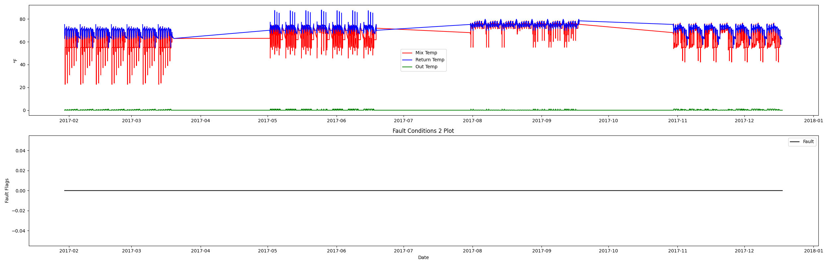

## Dataset Statistics

* Total time in days calculated in dataset: 322.0
* Total time in hours calculated in dataset: 7727.983333333334
* Total time in hours for when fault flag is True: 0.0
* Percent of time in the dataset when the fault flag is True: 0.0%
* Percent of time in the dataset when the fault flag is False: 100.0%
* Calculated motor runtime in hours based off of VFD signal > zero: 3040.22
* No faults were found in this given dataset.

# Summary Statistics filtered for when the AHU is running

### Mix Temp

* count 182413.000000  
  mean 64.259863  
  std 8.016277  
  min 22.610000  
  25% 55.090000  
  50% 64.240000  
  75% 72.210000  
  max 78.720000  
  Name: AHU: Mixed Air Temperature, dtype: float64

### Return Temp

* count 182413.000000  
  mean 71.168489  
  std 3.472873  
  min 54.470000  
  25% 70.110000  
  50% 71.830000  
  75% 73.890000  
  max 87.870000  
  Name: AHU: Return Air Temperature, dtype: float64

### Outside Temp

* count 182413.000000  
  mean 0.318123  
  std 0.352596  
  min 0.000000  
  25% 0.000000  
  50% 0.140000  
  75% 0.473400  
  max 1.000000  
  Name: AHU: Outdoor Air Damper Control Signal, dtype: float64

## Suggestions based on data analysis

* an AI-powered HVAC specialist, I have analyzed the data provided for an air handling unit (AHU) and identified some key insights. The AHU is responsible for mixing the return air and outdoor air streams to provide a comfortable indoor environment. The mixing air temperature should always be between the return and outside air temperatures, as dictated by thermodynamics. The data shows that the AHU appears to be averaging a mixing temperature, a return air temperature, and an outside air temperature based on the conditions given in the dataset.  
    
  The fault detection dataset indicates that the fan system is running for a total of 3040.22 hours, which is approximately equal to the total hours of data provided. This suggests that the fan system is running continuously, which could lead to high electrical energy consumption. If the faults are high, it may indicate that the AHU has mechanical issues, such as not being duct static pressure setpoint. On the other hand, if the faults are low, it suggests that the AHU is operating fine and meeting duct static pressure requirements.  
    
  The summary statistics of the sensor data show that the mixing air temperature has a mean of 64.26 degrees Fahrenheit, the return air temperature has a mean of 71.17 degrees Fahrenheit, and the outside air temperature has a mean of 0.32. These statistics provide insights into the AHU's operations and can be used to identify trends over time. For example, if the mixing air temperature is consistently too low, it could indicate that the AHU is not functioning properly and may require maintenance.  
    
  In conclusion, based on the data provided, an AI-powered HVAC specialist would recommend scheduling the AHU fan to save electrical energy consumption if the total hours of data are approximately equal to the hours of motor runtime. Additionally, if the faults are low and the summary statistics of the sensor data are within acceptable ranges, the AHU appears to be operating fine. However, if the faults are high or the sensor data is consistently outside of acceptable ranges, it may indicate that the AHU has mechanical issues that require attention.

Report generated: Wed Jun 21 14:00:11 2023